

**ALAGAPPA COLLEGE OF TECHNOLOGY**

**ANNA UNIVERSITY-600025**

**NM Assignment / Digital Marketing**

|  |  |  |
| --- | --- | --- |
| NAME | REG.NO | Naan Mudhalvan ID |
| PREETHI P | 2020308027 | 68AD90A2815D763BE9D4FE95F8E1498E |

**1. Create a blog or website using Blogpost Customize the theme design and post new article with 500 words.**

[**https://preethi2001.blogspot.com/2023/08/minimalism-and-mental-health.html?m=1**](https://preethi2001.blogspot.com/2023/08/minimalism-and-mental-health.html?m=1)

2. Create a New Facebook Business Page and post one social media poster for your brand.

[**https://www.facebook.com/profile.php?id=61550520372751&mibextid=ZbWKwL**](https://www.facebook.com/profile.php?id=61550520372751&mibextid=ZbWKwL)

3. Create and design a social media advertisement poster using canva.

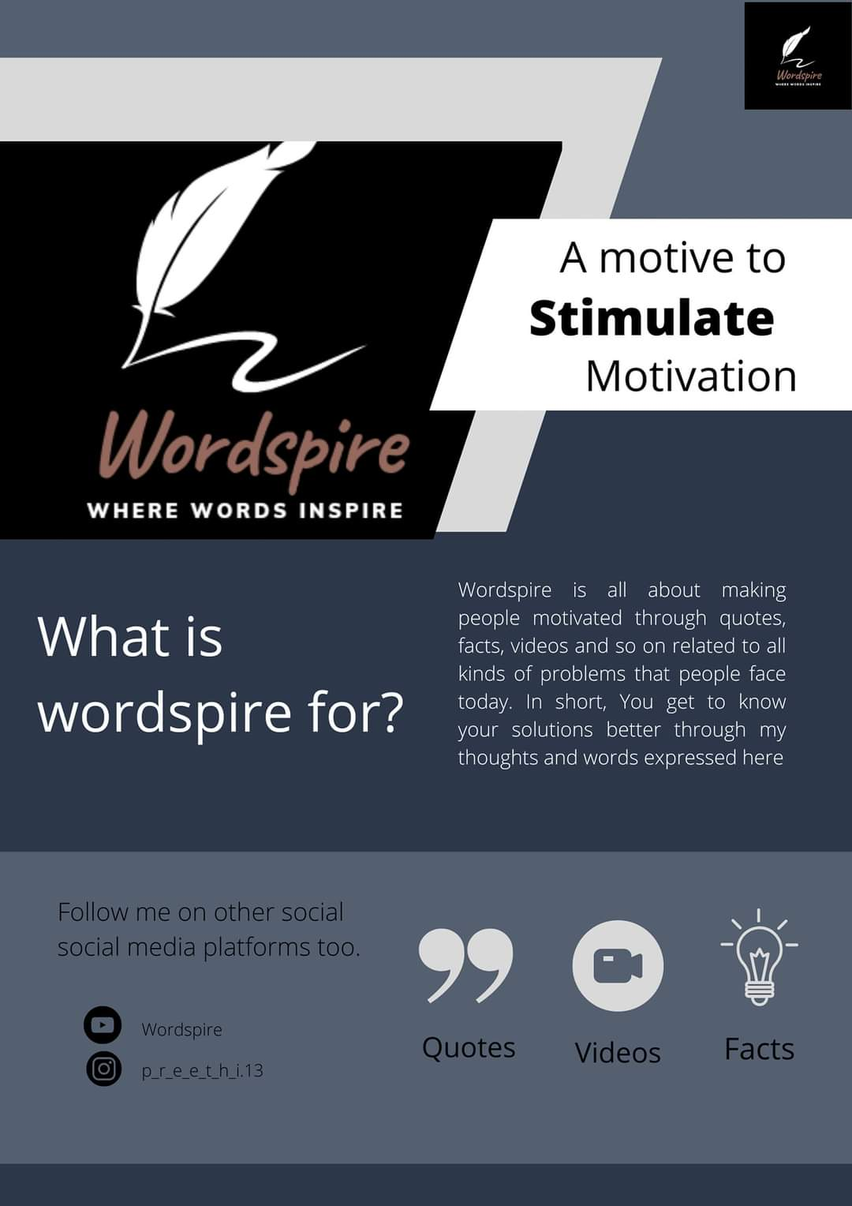

4. Create email newsletter design using MailChimp or canva tool.

